| **Course Name:** | **Elements of Electrical and Electronics Engineering** | **Semester:** | **I/II** |
| --- | --- | --- | --- |
| **Date of Performance:** | **27/12/22** | **Batch No:** | **C2-2** |
| **Faculty Name:** | **Jyoti Varavedkar** | **Roll No:** | **16010122109** |
| **Faculty Sign & Date:** |  | **Grade/Marks:** | **/ 25** |

**Experiment No: 10**

**Title:** **Inverting and Non-inverting amplifier using OPAMP**

| **Aim and Objective of the Experiment:** |
| --- |
| * To understand inverting configuration of OPAMP * To understand Non-inverting configuration of OPAMP * the concept of negative feedback and closed loop configuration of OPAMP. * To understand gain of inverting and non-inverting OPAMP |

| **COs to be achieved:** |
| --- |
| **CO5:** Understand operational amplifier and its applications |

| **Circuit Diagram/ Block Diagram:** |
| --- |
| **Pin diagram of IC 741**    Pin Configuration of 741 Op-amp Diagram    **Procedure**     1. Click on following link for Virtual lab experiment.   [http://vlabs.iitkgp.ac.in/be/exp17/index.html#](http://vlabs.iitkgp.ac.in/be/exp17/index.html)     1. Go through the theory, solve pre-quiz. 2. Go to simulation and perform the experiment by following the given procedure. 3. Prepare observation table, plot the graph based on observations. 4. Write conclusion based on observations. |

**Observations:**

**INVERTING:**

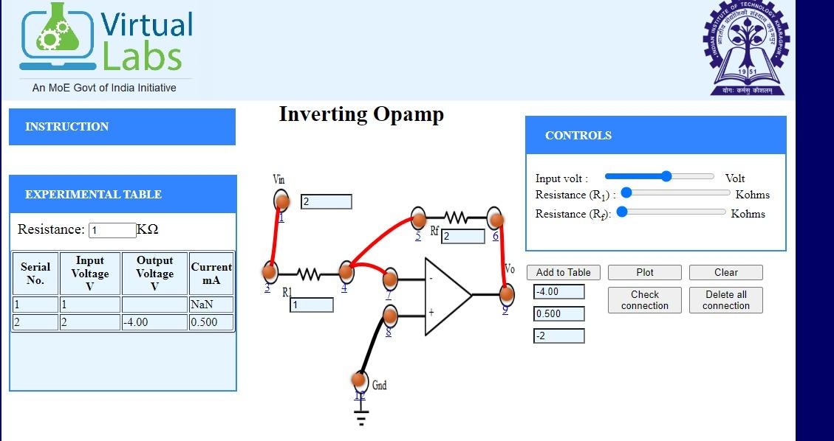

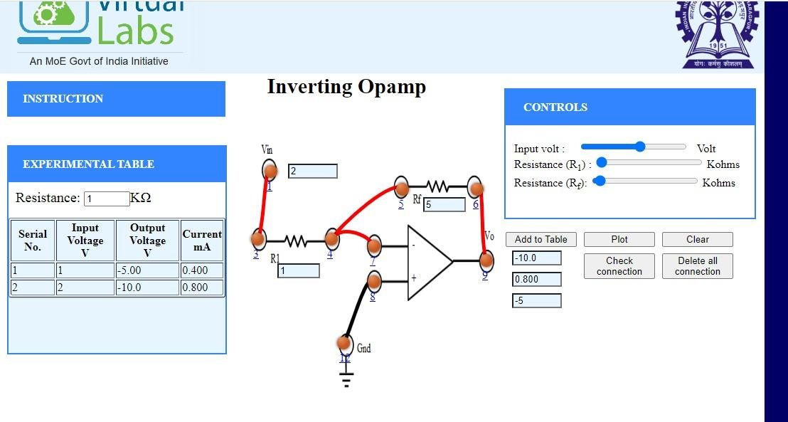

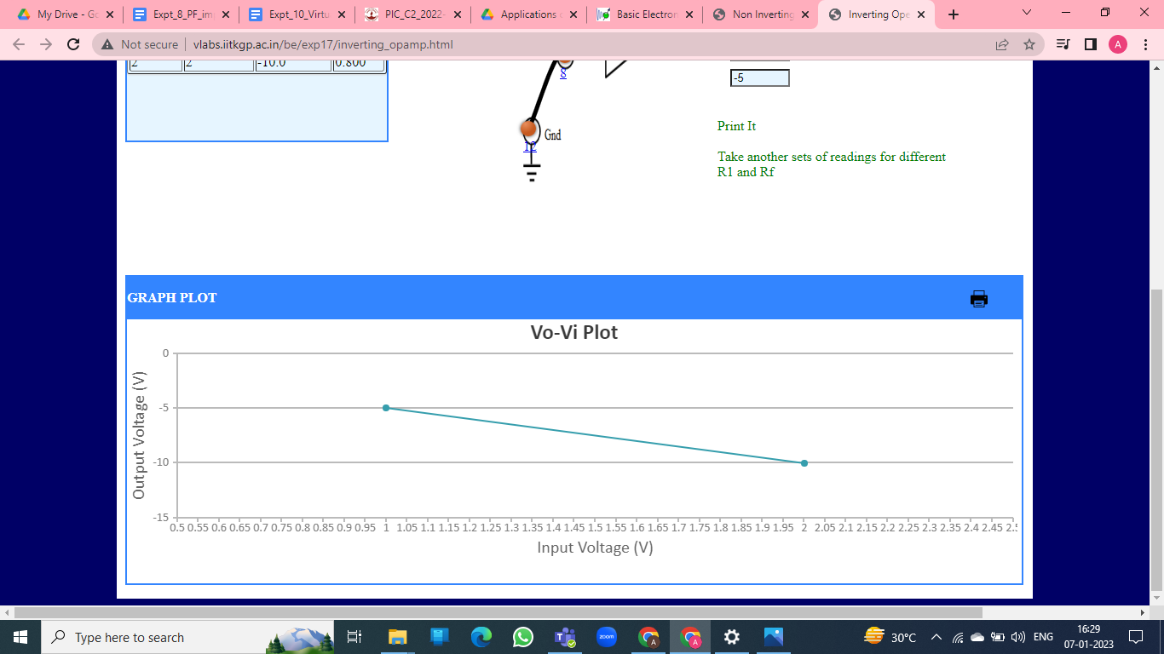

**NON - INVERTING :**

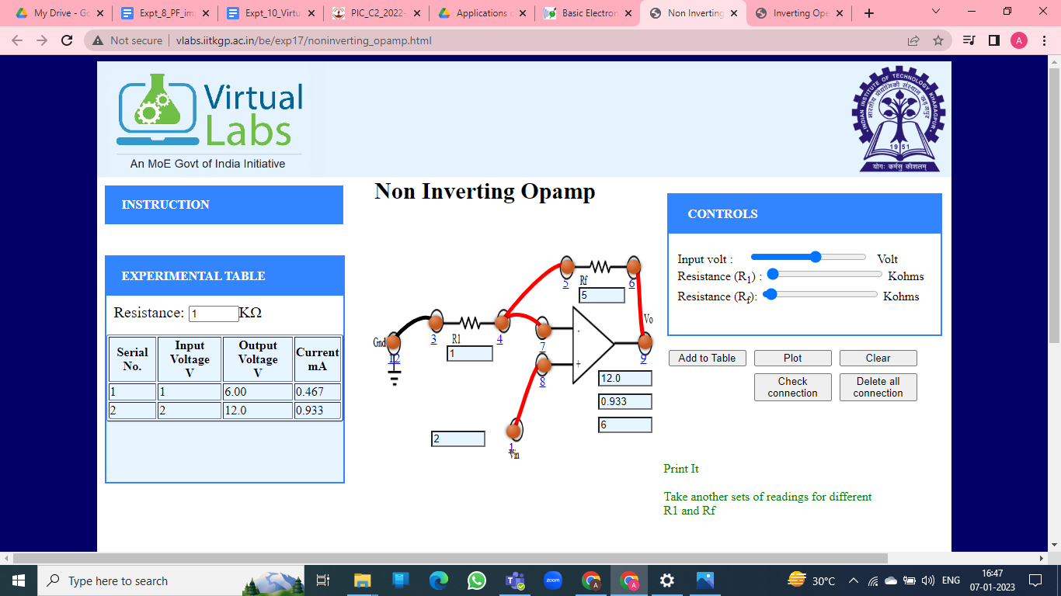

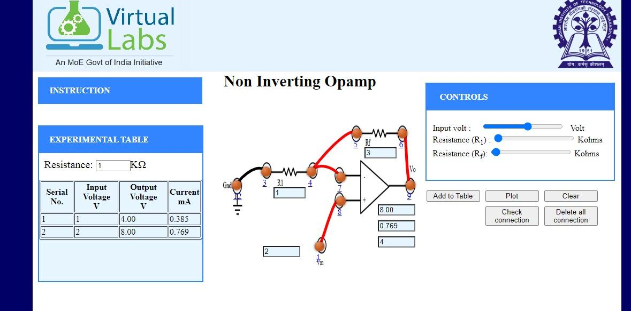

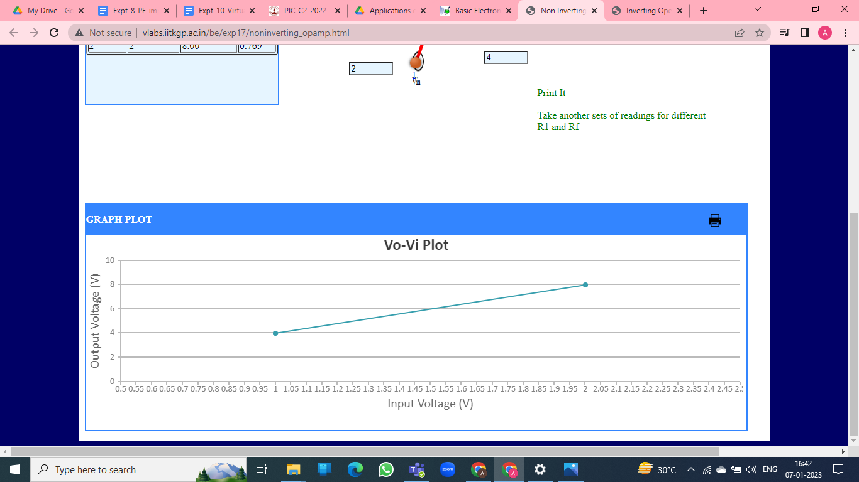

| **Conclusion:** |
| --- |
| Thus, we learnt the working of OPAMP in inverting and non-inverting configuration. |

| **Signature of faculty in-charge with Date:** |
| --- |